Community-Based Conservation Through Conservation Districts: The Keystone for Successful Conservation in Nevada

There are many successful models of conservation throughout the west (e.g., Utah Watershed Restoration Initiative, Restore New Mexico, Utah Community Based-Conservation Program, Coordinated Resource Management, and many others). It is asserted that the common thread of success for nearly every successful conservation model has been grounded in grass-roots as the community level.
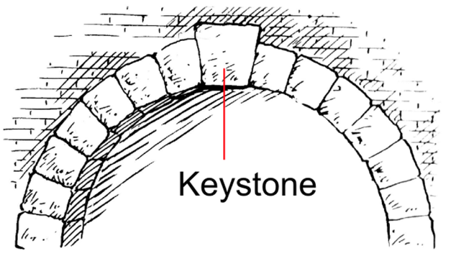
The community-based keystone entity must have the human and funding capacity to provide durability, longevity, and consistency. Where previous community-based efforts have had fits-and-starts that have ultimately failed (i.e., many of the CRM processes in the 1980s and 1990s), it is often primarily because of lack of capacity to keep the community-based structure in place.
While there are many community-based organization (CBO) that can organically take on the role as the keystone, there are few that have legal authority and responsibility to provide some certainty and stability. Conservation Districts (CD) are a natural fit to take on the role of the keystone but must be given the capacity to fulfill this imperative role.
Steps CDs (or any CBO) must take to properly set and maintain the community-based keystone:
- Build and maintain human and financial capacity;
- Develop and complete a LWG process that identifies local resource needs (i.e., resource needs assessment or RNA) with all interested stakeholders;
a. Engage facilitator network to complete this process.
- Develop conservation action plans (CAP) based on RNA;
- Implement CAPs; and
- Adaptive management – evaluate outcomes and adjust actions, RNA and CAP as needed.
a. Utilize the facilitator network to engage in the conflict resolution processes that crop up.

Nevada Association of Conservation Districts:
Nevada Association of Conservation Districts completed the final signatures for Cooperative Agreement 68-9104-17-004 with NV-NRCS on September 15, 2017 that states, “This agreement provides a cooperative working relationship between NRCS and NvACD in promoting and developing local work group areas and promoting viable candidates to participate on the NRCS State Technical Advisory Committee (STAC).” NvACD will provide training and templates to assist a minimum of six Nevada CDs (2 CD’s within each of the three areas) complete a Resource Needs Assessment by November 30, 2019. Upon completion these CD’s will participate in the STAC process at both the District and State levels specifying their resource needs determinations and priorities. NvACD and NRCS believes the information gained will inform a larger context as well:
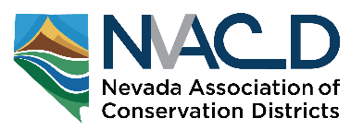
Our vision is community-based conservation, centered in conservation districts when they choose to lead, that will guide natural resource decision making and implementation in a local area. Too often there are multiple groups working and splitting the pie, getting in each other’s way, or just reducing effectiveness. Our belief, hope, expectation and desire is to encourage effective Local Work Groups, led by CDs that can be the nexus for much work that happens in a local area.

We believe there needs to be a paradigm shift in Nevada, where local communities are in the driver’s seat and are not just passengers. Locals must feel their input will be heard and utilized to the greatest degree possible that is also consistent with regulatory requirements. They must be empowered to devise and implement their desired actions.
The caveat is that state and federal agencies would participate in this process at the local level and obtain needed approval from the state and national levels such that their regulatory requirements will be recognized and adhered to throughout the process and when agreement is ultimately achieved the decision is legally actionable.

This effort recognizes NRCS as a major partner and utilizes NRCS planning models. This process will also promote CD participation in the STAC process. However, this effort in Nevada is to inform and empower CD’s to become conservation leaders, the Keystone conservation entity across all lands, ownerships, and jurisdictions in their area. To identify and resolve natural resource conservation concerns in their local area putting local communities in the driver’s seat, not just as passengers with federal and other state agencies at the wheel.

NvACD entered into this Agreement with NRCS to pursue our goal of encouraging locally led conservation in Nevada. We further believe that conservation districts should be the keystone players in the current Nevada Collaborative Conservation Network (http://sagebrusheco.nv.gov/About/Collaborative_Network/).
The Locally Led Principle (Conservation Districts- Your Community’s Gateway to Natural Resource Conservation NACD)
Locally led conservation is based on the principle that community stakeholders are best suited to identify and resolve local natural resource problems. Thus, community stakeholders are keys to successfully managing and protecting their natural resources. It challenges neighbors, both urban and rural, to work together and take responsibility for addressing local resource needs.

In the past, the term locally led has been used to describe a way of addressing natural resources needs—one that begins, is carried out and ends at the local level. Over the years, the term has been frequently used—perhaps overused at times—but its core concept remains the same and very relevant in the world of natural resource conservation.

The natural resource needs of the local community—whether a town, county, watershed or multi-county region—are at the core of the locally led process. It involves the community in the assessment of those needs, as well as the solutions and priorities. The approach emphasizes voluntary, non-regulatory, incentive-based approaches before use of regulatory measures. It is not driven by any single piece of legislation, any one fiscal year or any individual program; it is an on- going, timeless approach that is not tied to any particular year. As such, it is able to be evaluated regularly to ensure it is effectively meeting the long-term needs of the local community.

Locally led conservation is a grassroots effort to identify and resolve natural resource conservation concerns. It is essential in promoting and developing the stewardship ethic where people help each other in local communities to enhance and conserve those resources today for future generations.
NACD Secretary-Treasurer Jack Majeres

Locally led is not a program; it is a way of doing business, a way to effectively meet communities’ needs and get the right kind of conservation on the ground where it is most needed. For more info go to https://directives.sc.egov.usda.gov/viewerFS.aspx?hid=27713

Conservation Districts’ Role
Conservation districts hold a unique position on local, state and national levels. The nearly 3,000 conservation districts across the U.S.—each governed and staffed by local people—are the ideal facilitators for the locally led process. Districts are familiar with the land uses and needs in their communities, and they can build lasting relationships with their community stakeholders.
The Nevada Legislature statutorily establishes conservation districts as the legal local entity charged with local conservation and recognizes the special expertise of conservation districts in the following Legislative declarations: NRS 548.105 “It is hereby declared, as a matter of legislative determination, that persons in local communities are best able to provide basic leadership and direction for the planning and accomplishment of the conservation and development of renewable natural resources through organization and operation of conservation districts; and NRS 548.113 “It is hereby declared, as a matter of legislative determination, that conservation districts may be recognized as having special expertise regarding local conditions, conservation of renewable natural resources and the coordination of local programs which makes conservation districts uniquely suitable to serve as cooperating agencies for the purpose of the National Environmental Policy Act of 1969, 42 U.S.C. §§ 4321 et seq., and any other federal laws regarding land management, and to provide local government coordination for the purposes of the Federal Land Policy and Management Act of 1976, 43 U.S.C. §§ 1701 et seq., and any other federal laws regarding land management.”
Conservation districts have the duty, authority, and structure necessary to step forward and ensure the process begins, is carried out and ends at the local level, ultimately ensuring all the natural resource needs of their communities are met. They can do so by helping each community identify its needs and serving as a gateway between the community and outside technical, funding and educational resources, using a mix of federal, state, local and private sector programs as tools to solve local concerns.
Local Work Groups—Bringing Stakeholders through the District’s Front Door
Local Work Groups are another example of local leadership engaged in identifying and prioritizing needs. Much of the work of Local Work Groups has been focused on priority setting for Farm Bill Conservation Programs. But when districts assemble a work group and hold deliberations on local needs, the output of the process can and should be used for all of the district’s needs. A key improvement in the 2008 Farm Bill created local work groups as subcommittees of state technical committees. Local work groups are not limited in who can attend to contribute ideas and priorities.

Steps to Become Your Community’s Conservation Gateway
To position your conservation district as your local community’s gateway to conservation, there are several key steps you need to take:
- Public Outreach—obtain public participation
- Conservation Needs Assessment—assess the specific conservation needs of your community
- Identify and prioritize those needs
- Set goals
- Identify programs and funding sources to help meet those goals
- Develop the district’s area-wide conservation plan and/or strategic or long-range plan
- Implement your district’s plan(s)
- Measure performance

Once the information has been gathered through public outreach and the conservation needs assessment process, the next steps in the process involves the district board. The district board will need to
- set measurable conservation goals and objectives;
- identify conservation initiatives, systems and practices
- needed to achieve these goals and objectives; and
- identify federal, state, local and non-government programs and services that are available to address specific conservation needs.
As traditional funding sources decline or shift, this process will provide opportunities to examine new sources of assistance and new players to help carry out your conservation program. Here, again is another reason to include a large array of stakeholders in the input process. Expanding constituent and stakeholder participation increases the number of potential ideas, opportunities and financial resources available to carry out your goals. This process will help you identify ways to secure and coordinate support from a variety of sources.

The locally led process establishes a foundation upon which all of your district’s conservation efforts are based. It provides the informational and scientific rigor for planning and project implementation that is on par with other federal agency planning processes. From there, your district can pull the necessary resources from the state, federal, corporate and nonprofit sectors to carry out the conservation practices your community needs.

This process will ensure that the conservation work in your district is based on resource needs, not on programs and outside priorities. As a result, local elected officials, organizations, businesses and individuals as well as funders will recognize your district as the gateway to conservation assistance in your community—the role districts are meant to fill.

The Function of a Conservation District: To take available technical, financial and educational resources, whatever their source, and focus or coordinate them so that they meet the needs of the local land user for conservation of soil, water and related resources. Conservation districts develop and implement programs to protect and conserve soil, water, prime and unique farmland, rangeland, woodland, wildlife, energy, and other renewable resources on nonfederal lands. Districts also stabilize local economies and resolve conflicts in land use.

In Nevada and many other western states, where the federal government administers and manages significant portions of the land within the state, CD’s serve a vital role connecting private and public interests. NRS Chapter 548 grants CD’s specific duties and powers to develop and carry out District policies or Conservation Plans for the conservation and management of renewable natural resources across both private and federal land. Some of these duties and powers are:
- NRS 548.105 Legislative declaration - “It is hereby declared, as a matter of legislative determination, that persons in local communities are best able to provide basic leadership and direction for the planning and accomplishment of the conservation and development of renewable natural resources through organization and operation of CD’s.
- NRS 548.113 officially states that CD’s “may be recognized as having special expertise regarding local conditions, conservation of renewable resources and the coordination of local programs which make conservation districts uniquely suitable to serve as cooperating agencies for the purpose of the National Environmental Policy Act of 1969, 42 U.S.C. §§ 4321 et seq.
- The 2008 Farm Bill provided an allowance to expend EQIP funds on federal lands where resource issues and impacts extend across ownership and management boundaries creating new opportunity.
- The National Association of Conservation Districts (NACD) and the United States Bureau of Land Management (BLM) signed a Memorandum of Understanding (MOU) providing for a cooperative working relationship between the NACD and the BLM on July 16, 2013. This MOU recognizes and supports the role of Conservation Districts taking the leading role in administering Locally Led Conservation practices and provides for national and local sharing of technical, fiscal and administrative support to local conservation districts.
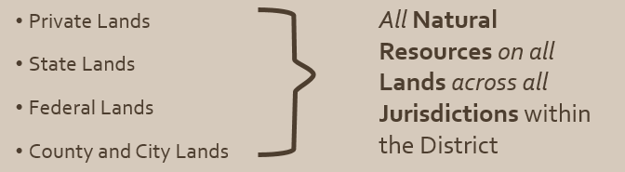

Conservation District Authorities:
Conservation District Law NRS 548 and NAC 548.
The Nevada Legislature statutorily establishes conservation districts as the legal local entity charged with local conservation and recognizes the special expertise of conservation districts in the following Legislative declarations: NRS 548.105 “It is hereby declared, as a matter of legislative determination, that persons in local communities are best able to provide basic leadership and direction for the planning and accomplishment of the conservation and development of renewable natural resources through organization and operation of conservation districts; and NRS 548.113 “It is hereby declared, as a matter of legislative determination, that conservation districts may be recognized as having special expertise regarding local conditions, conservation of renewable natural resources and the coordination of local programs…”.
NRS 548.113 further states that “Recognizing the importance of locally led efforts for the conservation of renewable natural resources, the Legislature will strive to provide appropriations to conservation districts at a level comparable to the appropriations provided to similar districts in other western states”.
The following is a partial list of Conservation District Authorities Granted by state statute:
- NRS 548.340 Conservation district is governmental subdivision; exercise of public powers.
- NRS 548.345 Surveys, investigations and research
- NRS 548.350 Demonstrational projects
- NRS 548.355 Preventive and control measures; repair and restoration of property:
- NRS 548.360 Cooperation and agreements with agencies for conserving renewable natural resources
- NRS 548.365 Availability of agricultural and engineering machinery, fertilizer and seeds
- NRS 548.370 Construction, operation and maintenance of facilities and structures
- NRS 548.375 Comprehensive plans for conservation
- NRS 548.380 Administration of projects; acceptance of gifts; participation in cost-sharing on federally financed projects.
- NRS 548.400 Cooperation between districts.
- NRS 548.405 Cooperation of state agencies and political subdivisions; applicability of regulations for use of land to publicly owned land:

In many Counties the Conservation District may be the only entity capable of developing and formalizing a natural resource plan (Conservation Plan) or policies that are District or county wide and they have the ability to work across boundaries of both public and private land. Therefore it is logical and statutorily correct to utilize Conservation Districts as the default entity to initiate locally led or community based conservation.

Nevada Collaboration Conservation Network NCCN
The State of Nevada, the US Forest Service, and the Bureau of Land Management are working together to use the Nevada Collaboration Conservation Network (NCCN) to achieve effective conservation of sagebrush ecosystems in Nevada in conjunction with implementation of the sage-grouse plan amendments. The NCCN empowers both stakeholders and land managers to cooperatively resolve conflict and build a collaborative position whether the discussion is at the local level, or when appropriate, referred to the Governor’s Sagebrush Ecosystem Council. The roles of Local Area Working Groups, agency field managers, and the Sagebrush Ecosystem Council are described in the NCCN Concept Paper (http://sagebrusheco.nv.gov/uploadedFiles/sagebrusheconvgov/content/About/nccn_roles_responsibilities.pdf)
The premise for the NCCN is that our best results for effective conservation and economic viability will be accomplished by working collaboratively at the ground level and from the bottom up. The NCCN is a process to enhance meaningful communication within a network structured to support local, diverse stakeholder groups who adopt a collaborative planning approach to conservation that incorporates best science with local knowledge.
The objective of the NCCN is to enhance the connectedness of communities to land management agencies because of their valuable contributions to conservation and resource management, and to create an environment to work across boundaries to mitigate conflict at the local level before turning to other options such as litigation. If situations arise where resolution of differences cannot be found at the local level, the dispute can be referred to the Nevada Sagebrush Ecosystem Council for their review and deliberation; ultimately resulting in consensus recommendations for a path forward. The success of this approach is exemplified by long standing groups like the Blackfoot Challenge in Montana, The Blue Mountain Forest Collaborative in Oregon, the Diablo Trust in Arizona, and the Shoesole group in northeastern Elko County, Nevada.
“To build partnerships by demonstrating the benefits of collaboration and community based conservation”
The formation of the Nevada Collaborative Conservation Network provides a great opportunity for Community Based or Locally Led Conservation. Participants identified an overall desire for this network to achieve Sagebrush ecosystem enhancement in addition to implementation of the sage-grouse plan amendments. Community Based Conservation, which is initiated and developed at the local level and is beneficial to both the community and natural resources is imperative in order to regain local trust, input and acceptance for implementation of any meaningful land management actions going forward. Conservation Districts (CD) are a natural fit to take on the role of the keystone but must be given the capacity to fulfill this imperative role.

The NCCN workshop recognized and identified that Nevada is a unique and diverse state where implementation of federal land use plan amendments is best understood and accomplished by incorporating local science and knowledge provided by those closest to the land. In order for federal land management agencies like the BLM and U.S. Forest Service to successfully implement management of federal lands, collaboration between the state, federal, and local partners operating in an adaptive management environment is essential. Locally Led Conservation is a longstanding model and framework to participate in the NCCN process and become the Keystone entity.

There is more opportunity for involvement and real beneficial impact at the local level than ever before. But in order to realize the benefits, local people must become involved at the local level with their CD to make the opportunity become the reality.

NvACD Resource Needs Assessment Guide
The NvACD Resource Needs Assessment Guide will explain the steps for a conservation district to follow to conduct an inventory of resource issues and concerns and begin to utilize the information gained to create a Conservation Needs Assessment and subsequent Conservation Action Plans. The process will generate input for Local Work Groups to provide recommendations to the NRCS State Technical Advisory Committee and ultimately assist coordination and cooperation with federal, state and local planning and implementation of planning in your area…….

Input from a broad range of agencies, organizations, businesses, and individuals in the local area that have an interest in natural resource management and are familiar with local resource needs and conditions is an essential element of locally led conservation. These representatives should reflect the diversity of the residents, landowners, and land operators in the local area.

The Locally Led Conservation using Resource Needs Assessment process
Produces:
- Local Resource Needs Assessment based on Resource Concerns
- Conservation Needs, Priorities, and Program Funding Recommendations for the STAC process
- Create an informed foundation for making decisions about local priorities or policies in all local conservation programs that is based upon Natural Resource conditions, local input, and is scientifically established to direct local projects and cooperate with State and Federal Resource Management in the District

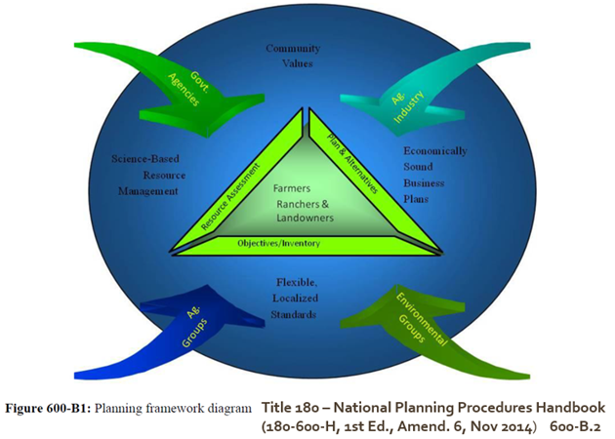

As CDs complete the Resource Concerns list and gather information from various agencies such as Bureau of Land Management, US Forest Service, Nevada Department of Wildlife, Nevada Department of Environmental Protection, Natural Resources Conservation Service, among others, CDs will need technical help to combine all the information (GIS layers, other info) and begin to draft the documents to retain the info and provide input to the STAC and other federal and state planning processes.

The Conservation Action Plan strives to balance natural resource issues with economic and social needs through the development of the conservation plan and provides a defensible scientific basis for conservation actions. This provides the District and proposed District actions considerable weight and basis when dealing with other agencies and entities.

NvACD recognizes that CD’s or specifically CD Boards of Supervisors in Nevada are managed by elected officials that are volunteers with full time jobs or businesses to operate and therefore, may have a great amount of expertise to offer their District but very limited time to participate in important but time intensive functions such as a detailed and well implemented Resource Inventory, Needs Assessment, and Conservation Action Planning process. Very few CD’s have the funding to hire staff to manage the day-to-day functions and provide capacity and continuity necessary for efficient and timely operation of the District. Supervisors provide leadership, motivation, and organizational skills. However, many functions above basic operations rely on reaching out to the community to find other volunteers that are passionate about conservation. These volunteers can assist in finding funding and providing input to the CD as committee members.
Conservation districts are the logical group to coordinate locally led conservation due to their connections to Federal, State, Tribal, and local governments; private resources; and the public. Therefore, further discussion of the locally led effort presumes that districts will provide primary leadership; however, leadership can come from any willing and interested group. Locally led conservation begins with the community itself, working through the local conservation district. It is based on the principle that community stakeholders are best suited to deal with local resource problems. While there is a wide range of groups that may be in a position to lead a local conservation effort, conservation districts, under State or Tribal law, are charged with facilitating cooperation and agreements between agencies, landowners, and others; developing comprehensive conservation plans; and bringing those plans to the attention of landowners and others in their district. Thus, conservation districts are recognized and legally authorized at the state and federal level as the entity to lead local conservation efforts. Conservation districts are recognized as being experienced in assessing resource needs, determining priorities, and coordinating programs to meet those needs and priorities.
The Board provides leadership and assistance but the community must become involved if Locally Led Conservation is to succeed. This process is designed around the concept of community involvement as a foundational principle.
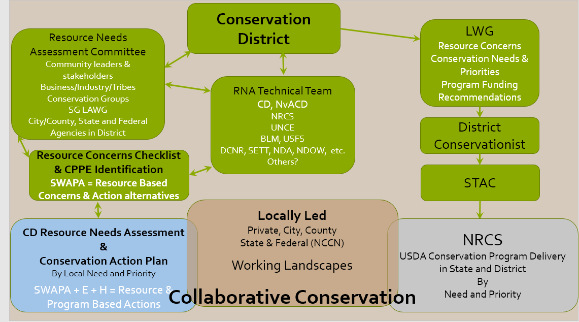

The resource concerns inventory, subsequent conservation needs assessment and resulting district conservation action plan will form a foundation upon which all local conservation efforts should be based i.e. Collaborative Locally Led Conservation.

For more information about Locally Led Conservation and Resource Needs Assessments please contact:

NEVADA ASSOCIATION OF CONSERVATION DISTRICTS

c/o Maggie Orr
PO Box 145
Caliente, NV 89008
www.nvacd.org
president@nvacd.org

Gary McCuin
PO Box 613
Eureka, NV 89316
Eureka Cooperative Extension
gmccuin@unce.unr.edu
775.237.5326

