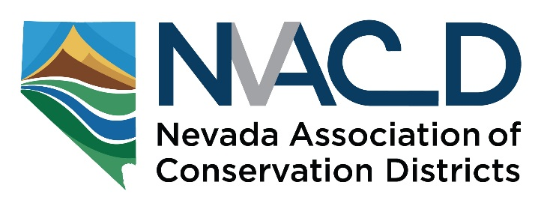

Resource Needs Assessment Summary

At the Annual Meeting NvACD introduced the Cooperative Agreement we signed with NV-NRCS to assist six Nevada CDs develop a Resource Needs Assessment. The Resource Needs Assessment process will begin when a conservation district brings together local producers, local groups, agencies and general public to identify resource concerns by means of the detailed NRCS Resource Concerns Inventory checklist used for farm planning. This is the key, to first identify the resource concerns before adding in the human element. Local knowledge and agency GIS layers and other data will inform the process with the results being run through NRCS’ Conservation Practices Physical Effects (CPPE) matrix to identify appropriate solutions to remedy the resource concerns.

CD Resource Needs Assessment Process will:
- Provide a foundation for Locally Led conservation actions and management of resources
- Inform the STAC process to prioritize NRCS funding on a state and local basis for District projects
- Ensure that your conservation programs address the most important local resource needs in a manner acceptable to your community objectives

We are developing a Guide and outreach materials to assist CDs reach out to many groups/entities/public to inform them about CDs and how this process can help them with locally led conservation. The Guide will explain the steps for a conservation district to follow to conduct an inventory of resource concerns and begin to utilize the information gained to create a Resource Needs Assessment and subsequent Conservation Action Plans. We are working with UNR/UNCE to develop a sophisticated survey instrument to obtain public input to assist CD’s in determining stakeholder conservation priorities and objectives. The process will generate input for Local Work Groups to provide recommendations to the NRCS State Technical Advisory Committee and ultimately assist coordination and cooperation with federal, state and local planning and implementation of planning in your area.
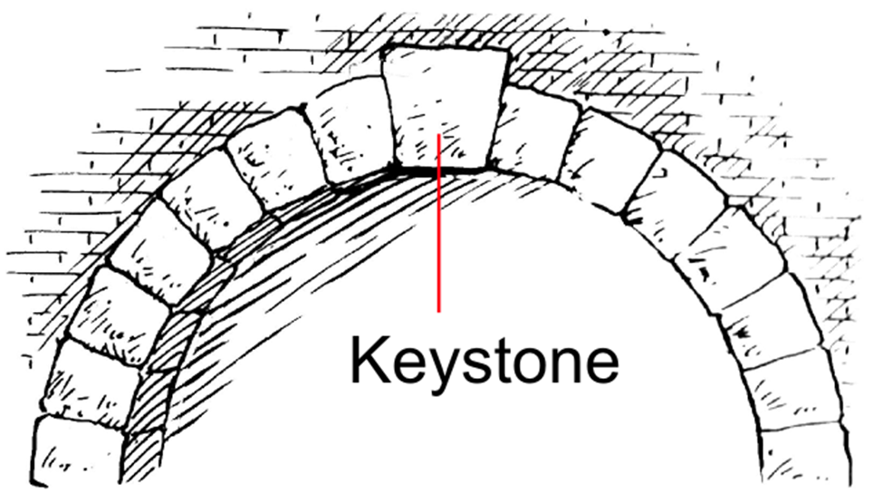
Locally Led Conservation
The following outlines an abbreviated RNA process:
District: Comprehensive stakeholder input & and participation
- Identify, Analyze, Map - Resource Concerns
- Identify stakeholder conservation priorities & objectives (Survey Instrument)
CD
- Identify and analyze potential conservation practices (CPPE)
District: Board of Supervisors
- Develop Conservation Action Plan
- Implement Conservation Action Plan (AOP)
Inform STAC process for NRCS funding and project priorities
- Review and adjust as necessary (3-5 years)

We are excited about this opportunity; we know it will require much effort; but we think it is a powerful way to lead locally led conservation and we think CDs should be those leaders!

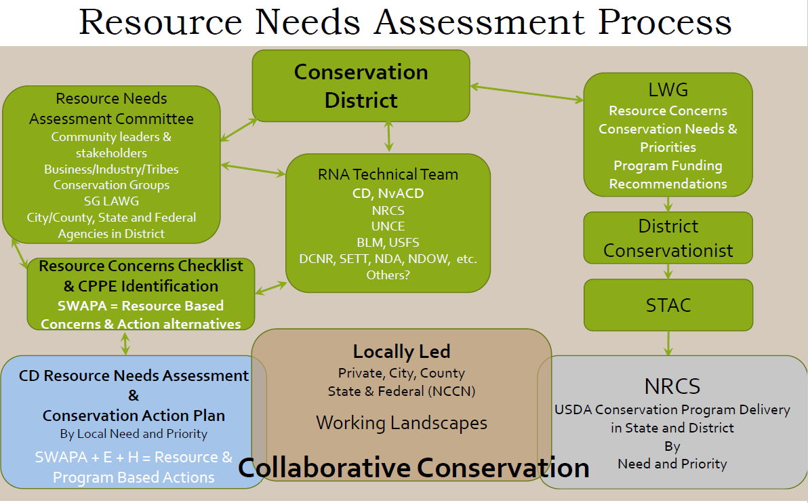
For more information, contact
Maggie Orr, President Gary McCuin, 2nd Vice-President
Lincoln County CD Eureka CD
P.O. Box 145 P.O. Box 631
Caliente, NV 89008 Eureka, NV 89316-0613
(775) 726-3742 (775) 237-5326
President@nvacd.org mccuing@unce.unr.edu

